.


Compensation and Pension Record Interchange (CAPRI)

Health Revenue Center Menu Changes HRC MENU DISTRIBUTION - PHASE II

Release Notes

Patch: DVBA*2.7*148

July 2010

Department of Veterans Affairs
Office of Enterprise Development
Management & Financial Systems

Preface
Purpose of the Release Notes
The Release Notes document describes the new features and functionality of patch DVBA*2.7*148 (Subject: HRC MENU DISTRIBUTION - PHASE II.)

Reference Numbering System
This document uses a numbering system to organize its topics into sections and to show the reader how these topics relate to each other. For example, the information in section 1.3 is the main topic for the third section of Chapter 1. If there were two subsections to this topic, they would be numbered 1.3.1 and 1.3.2. A section numbered 2.3.5.4.7 would be the seventh subsection of the fourth subsection of the fifth subsection of the third topic of Chapter 2. This numbering system tool allows the reader to more easily follow the logic of sections that contain several subsections.

Table of Contents
1. Overview 1
1.1 ESM Approves HRC Menu Enhancements 1
1.2 HRC First Party Call Center Background 1
1.3 HRC Menu Enhancements 1
2. Associated Remedy Tickets and New Service Requests 2
3. Enhancements 3
3.1 HRC First Party CC Menu Additions 3
3.2 HRC Pharmacy Menu Additions 4
3.3 New - HRC First Party Extended Services Menu 4
3.4 New - HRC Pharmacy Customer Care Menu 7
4. Technical Items 8
4.1 Added new ICR #5542 allowing access to additional Order Entry/ Results Reporting options. 8
4.2 Modified ICR #4590 allowing access to additional Accounts Receivable options 9
4.3 Modified ICR #4592 allowing access to additional Registration options 10
4.4 Modified ICR #4594 allowing access to additional Integrated Billing options 10
4.5 Modified ICR #4595 allowing access to additional Outpatient Pharmacy options 11
4.5.1. Notes 12
5. Software and Documentation Retrieval 13
5.1 Patch DVBA*2.7*148 (Subject: HRC MENU DISTRIBUTION - PHASE II) 13
5.2 User Documentation 13

Overview
The following section provides a high level overview of patch DVBA*2.7*148 (Subject: HRC MENU DISTRIBUTION - PHASE II.).

ESM Approves HRC Menu Enhancements
The Enterprise System Management (ESM) office has given Compensation and Pension Record Interchange (CAPRI) approval to provide the Health Revenue Center (HRC) First Party Call Center contact representatives with enhancements to the current HRC menu structure. Modifications will include two new menus and additional VistA options for two of the existing HRC menus distributed in patch DVBA*2.7*84 released on 12/22/2006.

HRC First Party Call Center Background
CAPRI provides local common service access to VistA for HRC CAPRI remote users. The CAPRI Enhancement project will be modifying the current HRC menu structure to support the needs of the HRC First Party Call Center. The HRC First Party Call Center contact representatives handle calls from veterans related to the Consolidated Co-payment Processing Center (CCPC) billing statements. Many of the questions received by the HRC First Party Call Center require research using VistA options from several packages including Accounts Receivable, Computerized Patient Record System (CPRS), Integrated Billing, Kernel, Pharmacy, and Registration. The HRC needs this information in order to provide 'first call resolution' to veterans.

HRC Menu Enhancements
This patch adds options from the Outpatient Pharmacy and Integrated Billing packages to the HRC First Party CC menu. Outpatient Pharmacy and Computerized Patient Record System (CPRS) options will be added to the HRC Pharmacy Menu. It also distributes two new menus called HRC First Party Extended Services and HRC Pharmacy Customer Care Menu. The options found in these menus will be existing VistA options from Accounts Receivable, Computerized Patient Record System, Integrated Billing, Outpatient Pharmacy, and Registration.

Associated Remedy Tickets and New Service Requests

There are no Remedy tickets and/or New Service Requests associated with patch DVBA*2.7*148 (Subject: HRC MENU DISTRIBUTION - PHASE II.)

Enhancements
The following section is an overview of the enhancements that will be delivered in the patch DVBA*2.7*148 (Subject: HRC MENU DISTRIBUTION - PHASE II) release.

HRC First Party CC Menu Additions
Two options from the Outpatient Pharmacy package and one option from the Integrated Billing package have been added to the HRC First Party CC menu [DVBA HRC MENU]. These additional options are as follows:
- Medication Profile [PSO P]
- View Prescriptions [PSO VIEW]
- ECME Billing Events Report [IB ECME BILLING EVENTS]

3.1 Example: HRC First Party CC Menu Screen Shot
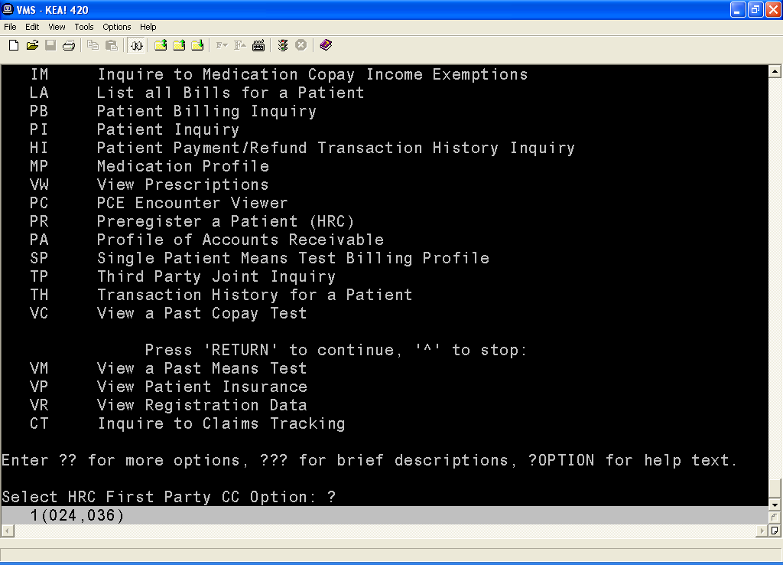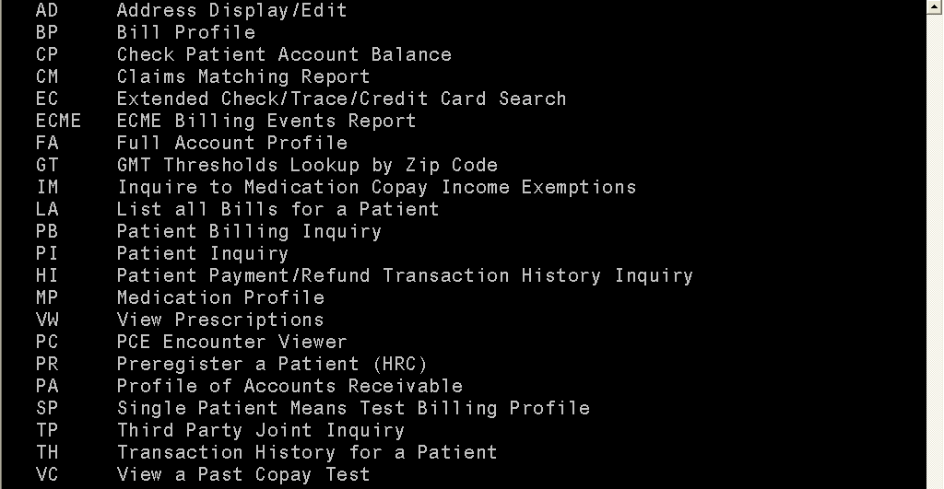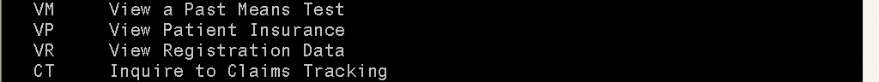

HRC Pharmacy Menu Additions
One option from the Outpatient Pharmacy and one option from the Computerized Patient Record System packages have been added to the HRC Pharmacy Menu [DVBA HRC MENU PHARMACY]. These options include:
- Patient Prescription Processing [PSO LM BACKDOOR ORDERS]
- Ward Clerk Menu [OR MAIN MENU WARD CLERK]

3.2 Example: HRC Pharmacy Menu Screen Shot
Select HRC Pharmacy Menu Option: ?

HRC HRC First Party CC ...
RC Reset Copay Status/Cancel Charges
PP Patient Prescription Processing
MP Medication Profile
VW View Prescriptions
WC Ward Clerk Menu ...

New - HRC First Party Extended Services Menu
The new HRC First Party Extended Services menu [DVBA HRC MENU EXTENDED SVCS] has been added. This menu contains several options from the Registration, Accounts Receivable and Integrated Billing packages. These options include:
- HRC First Party CC ... [DVBA HRC MENU]
- Fugitive Felon Program Main Menu ...[DGFFP FUGITIVE FELON PROGRAM]
- Manually Change Copay Exemption (Hardships) [IB RX HARDSHIP]
- Group Parameters [PRCA BIL AGENCY]
- Statement Parameters [PRCA NOTIFICATION PARAMETERS]
- Enter Lesser DMC Withholding Amount[PRCA RCDMC LESSER WITHHOLDING]
- COWC Referral [PRCAC COWC REFER]
- Re-Establish Bill [PRCAC TR RE-ESTABLISH BILL]
- Administrative Cost Adjustment [PRCAF ADJ ADMIN]
- Interest/Admin/Penalty Rates [PRCAF U ADMIN.RATE]
- Transaction Patient Statement History [RCBD TRANSACTION STMT HISTORY]
- Receipt Processing [RCDP RECEIPT PROCESSING]
- Summary SF215 Report [RCDP SUMMARY 215 REPORT]
- EDI Lockbox ... [RCDPE EDI LOCKBOX MENU]
- Suspend an AR bill [PRCAC TR SUSPENDED]
- Debtor Comment Log [PRCA DEBTOR COMMENT]
- List of Receipts Report [RCDP LIST OF RECEIPTS REPORT]

3.3a Example: HRC First Party Extended Services Menu Screen Shot
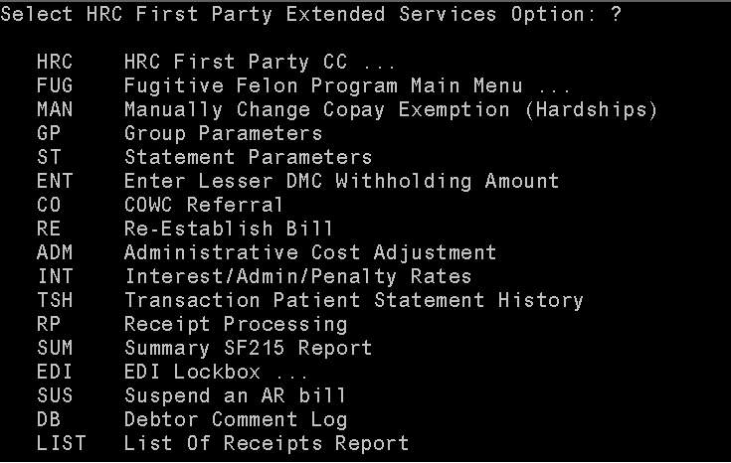

The HRC First Party Extended Services [DVBA HRC MENU EXTENDED SVCS] menu and the HRC Pharmacy Customer Care Menu [DVBA HRC MENU PHARMACY CC] are available to the HRC user as a secondary menu option until an updated version of the CAPRI GUI application is released.
Secondary menu options are available by entering the full or partial menu name or by entering two question marks (??) and selecting the HRC First Party Extended Services [DVBA HRC MENU EXTENDED SVCS] menu or HRC Pharmacy Customer Care Menu [DVBA HRC MENU PHARMACY CC] from the list of options.
Example - User accesses new HRC First Party Extended Services assigned as a secondary menu option by entering HRC as a partial menu name. The following example shows a user assigned the User’s Toolbox [XUSERTOOLS] menu as their primary menu accessing the HRC First Party Extended Services menu:

3.3b Example: HRC First Party Extended Services Menu Screen Shot
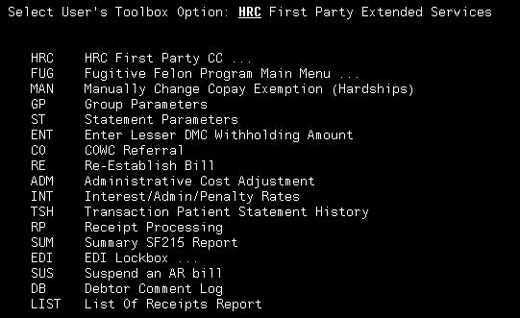

Example – User enters double question marks (??) to display primary menu and secondary menu options. Options displayed are dependent on the user’s primary and secondary menu assignments. The following example shows a user assigned the User’s Toolbox [XUSERTOOLS] menu as their primary menu accessing the HRC First Party Extended Services menu:
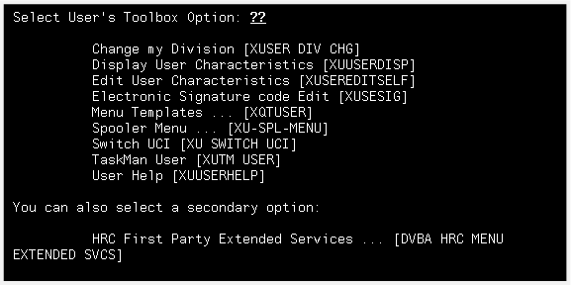
Note: When a CAPRI HRC remote user is assigned one of the existing three HRC menus as their primary menu and connects to a site through CLAIMS, the HRC user is assigned the HRC menu as their primary menu. However, this is not the same case for CAPRI HRC remote users assigned to one of the new HRC menus. The CAPRI GUI application has not yet been modified to recognize the new HRC First Party Extended Services and HRC Pharmacy Customer Care menus and assigns this menu as the user's primary menu at the remote site. An updated version of the CAPRI GUI application will be released in the future to recognize the two new HRC menus as a primary menu at the remote site.

New - HRC Pharmacy Customer Care Menu
A new menu, HRC Pharmacy Customer Care Menu [DVBA HRC MENU PHARMACY CC] has been added. This menu contains several options from the Outpatient Pharmacy package, an option from the Computerized Patient Record System (CPRS) package, and the HRC First Party CC [DVBA HRC MENU] menu. This option includes:
- HRC First Party CC ... [DVBA HRC MENU]
- Medication Profile [PSO P]
- View Prescriptions [PSO VIEW]
- Ward Clerk Menu [OR MAIN MENU WARD CLERK]

3.3 Example: HRC Pharmacy Customer Care Menu Screen Shot
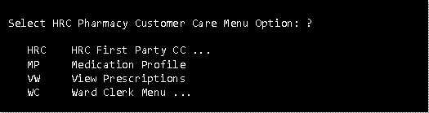

Technical Items
The following Integration Control Registrations (ICRs) have been added or modified.

Added new ICR #5542 allowing access to additional Order Entry/ Results Reporting options.
ICR REFERENCE: 5542
NAME: Ward Clerk Menu Access
CUSTODIAL PACKAGE: ORDER ENTRY/RESULTS REPORTING
SUBSCRIBING PACKAGE: AUTOMATED MED INFO EXCHANGE

The Health Revenue Center (HRC) is using the telnet functionality in the CAPRI application to view patient data across all VistA systems. CAPRI provides local common service to VistA for HRC CAPRI remote users and the HRC needs usage of the following menu option listed in this Integration Control Registration:

Ward Clerk Menu [OR MAIN MENU WARD CLERK]

USAGE: Controlled Subscription
ENTERED: JUN 29,2010
STATUS: Active
TYPE: Other
DESCRIPTION: The Ward Clerk Menu [OR MAIN MENU WARD CLERK] will be added to the HRC Pharmacy Menu [DVBA HRC MENU PHARMACY] option and the new menu, HRC Pharmacy Customer Care Menu [DVBA HRC MENU PHARMACY CC]. The Ward Clerk Menu option will be used by the HRC contact representatives and distributed in patch DVBA*2.7*148.
The HRC has provided the following justification for access to the Ward Clerk Menu option:
The request for the VistA option Ward Clerk Menu [OR MAIN MENU WARD CLERK] will provide additional functionality to flag renewal requests for provider action. Renewal of prescriptions that have expired or have no refills remaining constitute 26.1% of the calls fielded by the HRC Pharmacy Customer Care Center (PCCC). This type of call cannot be easily resolved by the facility pharmacies, because action on the part of the provider is required. With access to the option, the HRC agent can send a "View Alert" directly to the provider through VistA. The provider will receive the "View Alert" immediately upon being flagged by the HRC agent to ensure prompt attention and resolution of the required prescription renewal. Safeguards are built into the Ward Clerk version of the VistA option not allowing the HRC PCCC agent to discontinue copy, change or renew a prescription without verification by a facility clinician. CAPRI does recognize provider’s credentials, therefore any renewals flagged by HRC agents would not be processed until signed off by the provider.

Modified ICR #4590 allowing access to additional Accounts Receivable options
ICR RREFERENCE: 4590
NAME: DBIA4589-B
CUSTODIAL PACKAGE: ACCOUNTS RECEIVABLE
SUBSCRIBING PACKAGE: AUTOMATED MED INFO EXCHANGE

Usage of:
RCDP BILL PROFILE
RCDP CLAIMS MATCH
RCDP EXTENDED CHECK/CC SEARCH
PRCA PAYMENT TRANS HISTORY
PRCAC PROFILE
PRCA TRANS HISTORY
PRCAY FULL ACCOUNT PROFILE
PRCA VEN BIL
PRCA ACCOUNT CHECK
PRCAC TR SUSPENDED
PRCA DEBTOR COMMENT
PRCA BILL STATUS LISTING
PRCAC TR RE-ESTABLISH BILL
PRCA RCDMC LESSER WITHHOLDING
RCBD TRANSACTION STMT HISTORY
PRCAC COWC REFER
PRCAF ADJ ADMIN
PRCA NOTIFICATION PARAMETERS
RCDP RECEIPT PROCESSING
RCDP LIST OF RECEIPTS REPORT
RCDP SUMMARY 215 REPORT
RCDPE EDI LOCKBOX MENU
PRCA BIL AGENCY
PRCAF U ADMIN.RATE

USAGE: Controlled Subscription
ENTERED: FEB 3,2005
STATUS: Active
TYPE: Other
DESCRIPTION: The Health Revenue Center (HRC) will be using a special telnet feature in CAPRI-Remote to view patient data across all Vista Systems. They need access to the menu options listed in this IA in order to review various records for any given patient.

Modified ICR #4592 allowing access to additional Registration options
ICR RREFERENCE: 4592
NAME: DBIA4589-D
CUSTODIAL PACKAGE: REGISTRATION
SUBSCRIBING PACKAGE: AUTOMATED MED INFO EXCHANGE

Usage of:
DG CO-PAY TEST VIEW TEST
DG MEANS TEST VIEW TEST
DG REGISTRATION VIEW
DG PATIENT INQUIRY
DGPRE PRE-REGISTER OPTION
DGFFP FUGITIVE FELON PROGRAM

USAGE: Controlled Subscription
ENTERED: FEB 3,2005
STATUS: Active
TYPE: Other
DESCRIPTION: The Health Revenue Center (HRC) will be using a special telnet feature in CAPRI-Remote to view patient data across all Vista Systems. They need access to the menu options listed in this IA in order to review various records for any given patient.

Modified ICR #4594 allowing access to additional Integrated Billing options
ICR RREFERENCE: 4594
NAME: DBIA4589-F
CUSTODIAL PACKAGE: INTEGRATED BILLING
SUBSCRIBING PACKAGE: AUTOMATED MED INFO EXCHANGE

Usage of:
IBCN VIEW PATIENT INSURANCE
IB MT PROFILE
IBJ THIRD PARTY JOINT INQUIRY
IB RX INQUIRE
IB LIST ALL BILLS FOR PAT
IB OUTPUT FULL INQ BY BILL NO
IBT OUTPUT CLAIM INQUIRY
IB ECME BILLING EVENTS
IB RX HARDSHIP

USAGE: Controlled Subscription
ENTERED: JAN 25,2005
STATUS: Active
TYPE: Other
DESCRIPTION: The Health Revenue Center (HRC) will be using a special telnet feature in CAPRI-Remote to view patient data across all Vista Systems. They need access to the menu options listed in this IA in order to review various records for any given patient.

Modified ICR #4595 allowing access to additional Outpatient Pharmacy options
ICR REFERENCE: 4595
NAME: DBIA4589-G
CUSTODIAL PACKAGE: OUTPATIENT PHARMACY
SUBSCRIBING PACKAGE: AUTOMATED MED INFO EXCHANGE

Usage of:
PSOCP RESET COPAY STATUS
PSO P
PSO VIEW
PSO LM BACKDOOR ORDERS

USAGE: Controlled Subscription
ENTERED: FEB 10,2005
STATUS: Active
DURATION: Till Otherwise Agr
TYPE: Other
DESCRIPTION: The Health Revenue Center (HRC) will be using a special telnet feature in CAPRI-Remote. This allows a user to be automatically logged into the local VistA system and provides access to the site’s regular VistA functionality. The HRC requires access to the menu options listed in this Integration Agreement (IA) in order to access various records for a given patient.
HRC First Party Call Center contact representatives will use the HRC Pharmacy Menu [DVBA HRC MENU PHARMACY] option to handle calls from veterans related to the Consolidated Co-payment Processing Center (CCPC) billing statements. The menu option will be available through the CAPRI application, which provides local common service to VistA for HRC CAPRI remote users. Users of the HRC Pharmacy Menu [DVBA HRC MENU PHARMACY] option will typically be licensed and registered personnel (i.e. pharmacists and pharmacy technicians).

Notes
- The Reset Copay Status/Cancel Charges [PSOCP RESET COPAY STATUS] option may be used to change the patient’s Copay.
- Pharmacy Benefits Management endorses the addition of the Patient Prescription Processing [PSO LM BACKDOOR ORDERS] to the HRC Pharmacy Menu [DVBA HRC MENU PHARMACY] menu option, with the understanding that HRC users will not use the option to alter existing Outpatient Pharmacy records.

Software and Documentation Retrieval

Patch DVBA*2.7*148 (Subject: HRC MENU DISTRIBUTION - PHASE II)
The VistA software patch is being distributed as a PackMan patch message through the National Patch Module (NPM). The KIDS build for this patch is DVBA*2.7*148.

User Documentation
The user documentation for this patch may be retrieved directly using FTP. The preferred method is to FTP the files from:

download.vista.med.va.gov

This transmits the files from the first available FTP server. Sites may also elect to retrieve software directly from a specific server as follows:

OI&T Field Office | FTP Address | Directory
Albany | ftp.fo-albany.med.va.gov | [anonymous.software]
Hines | ftp.fo-hines.med.va.gov | [anonymous.software]
Salt Lake City | ftp.fo-slc.med.va.gov | [anonymous.software]

The following files will be available:

File Name | Format | Description
DVBA_27_P148_RN.PDF | Binary | Release Notes

The VistA Documentation Library (VDL) web site will also contain the 'DVBA*2.7*148 Release Notes'. This web site is usually updated within 1-3 days of the patch release date.

